WEB 420 Discussion 1.1

Application state is simply information where you are in an application or website during your interaction with the server on which the application or website resides[1]. In other words, if you are on the About page of a company’s website, that is the application state. Resource state, on the other hand, is the data that is stored on a server that lasts longer than just during your interaction with the server. Images or messages uploaded to a server, for instance, constitute resource state. So, if a website has an image of a cat on it, that is a resource state, and that state will remain until the picture is removed. If you view the image of the cat on your computer, that is application state, and it lasts only so long as you are viewing the picture.

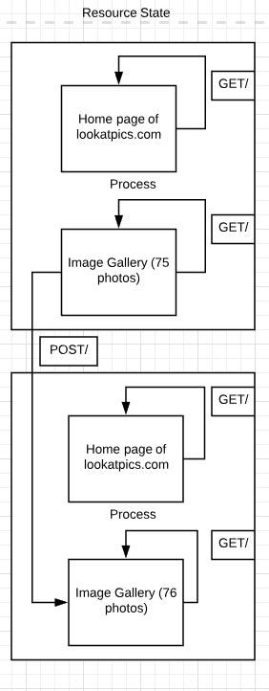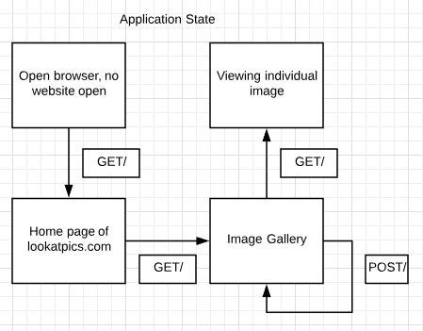

1. Ruben Verborgh. (2012, Aug 24). REST, Where’s My State? (article). Retrieved from <https://ruben.verborgh.org/blog/2012/08/24/rest-wheres-my-state/>